**Shell Scripting Programs (PART 2)**

1. Write a shell program to find the sum of squares of first n numbers (use while).

#!/bin/bash

# Read n from the user

echo "Enter the value of n:"

read n

sum=0

i=1

# Using while loop

while [ $i -le $n ]

do

square=$((i * i))

sum=$((sum + square))

i=$((i + 1))

done

echo "The sum of squares of first $n numbers is: $sum"

**output**

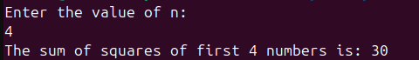

1. Write a menu driven shell program to find the sum, difference, product, quotient of 2 numbers.

#!/bin/bash

# Read two numbers

echo "Enter first number:"

read a

echo "Enter second number:"

read b

while true

do

echo ""

echo "Choose an operation:"

echo "1. Sum"

echo "2. Difference"

echo "3. Product"

echo "4. Quotient"

echo "5. Exit"

read choice

case $choice in

1)

sum=$((a + b))

echo "Sum = $sum"

;;

2)

diff=$((a - b))

echo "Difference = $diff"

;;

3)

prod=$((a * b))

echo "Product = $prod"

;;

4)

if [ $b -ne 0 ]; then

quot=$((a / b))

echo "Quotient = $quot"

else

echo "Cannot divide by zero."

fi

;;

5)

echo "Exiting program. Goodbye!"

break

;;

*)

echo "Invalid choice. Please select 1-5."

;;

esac

done

**output**

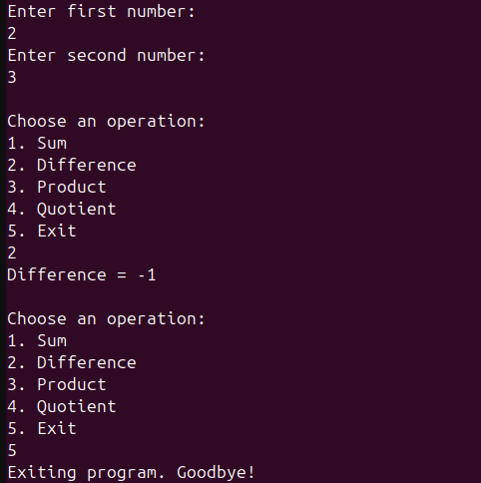

1. Write a menu driven shell program to find the month if a number gives (repeat the menu infinitely).

#!/bin/bash

while true

do

echo ""

echo "Enter a number (1-12) to find the month:"

echo "Enter 0 to Exit."

read num

case $num in

1) echo "January" ;;

2) echo "February" ;;

3) echo "March" ;;

4) echo "April" ;;

5) echo "May" ;;

6) echo "June" ;;

7) echo "July" ;;

8) echo "August" ;;

9) echo "September" ;;

10) echo "October" ;;

11) echo "November" ;;

12) echo "December" ;;

0)

echo "Exiting program. Goodbye!"

break

;;

*)

echo "Invalid input! Please enter a number between 1 and 12, or 0 to exit."

;;

esac

done

**output**

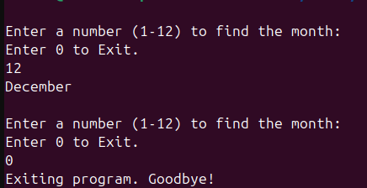

1. Write a shell program to find the factorial of a number (Use function).

#!/bin/bash

# Function to calculate factorial

factorial() {

num=$1

fact=1

while [ $num -gt 1 ]

do

fact=$((fact * num))

num=$((num - 1))

done

echo $fact

}

# Read a number from the user

echo "Enter a number:"

read n

# Call the function and display the result

result=$(factorial $n)

echo "Factorial of $n is: $result"

**output**

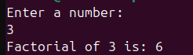

1. Write a shell program to print the Fibonacci numbers upto N.

#!/bin/bash

# Read N from the user

echo "Enter how many Fibonacci numbers to print:"

read n

# First two Fibonacci numbers

a=0

b=1

echo "Fibonacci series up to $n terms:"

i=0

while [ $i -lt $n ]

do

echo -n "$a "

fn=$((a + b))

a=$b

b=$fn

i=$((i + 1))

done

echo "" # Print a newline at the end

**output**

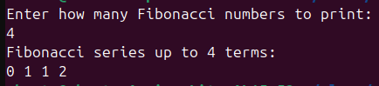

1. Read a Decimal number. Convert it to Binary and display the result (Use while).

#!/bin/bash

# Read a decimal number

echo "Enter a decimal number:"

read num

binary=""

# Edge case for 0

if [ $num -eq 0 ]; then

echo "Binary: 0"

exit 0

fi

# Use while loop to convert to binary

while [ $num -gt 0 ]

do

rem=$((num % 2))

binary="$rem$binary" # Prepend the remainder

num=$((num / 2))

done

echo "Binary: $binary"

**output**

